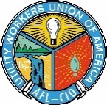
Contact
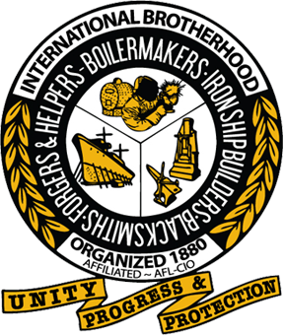

Amy Wiser
Director of Communications, Boilermakers
317-847-0745
awiser@boilermakers.org

Erin Bzymek
Director of Communications, UWUA
202-702-9655
ebzymek@uwua.net

IMMEDIATE RELEASE

Boilermakers and Utility Workers Sign Historic Union Affiliation Agreement

CHICAGO (May 13, 2019) – The International Brotherhood of Boilermakers and Utility Workers Union of America (UWUA) signed an affiliation agreement Wednesday, May 8, 2019, that calls for the two trade unions to join together for mutually beneficial strategies that leverage both organizations’ strengths.

While the affiliation agreement is not a merger of the two unions, it calls for the Boilermakers and UWUA to share in areas and opportunities that naturally align, such as special projects, industry programs and infrastructure, resources and other cooperative efforts.

“The International Brotherhood of Boilermakers and the Utility Workers Union of America have much in common in terms of our structures, our challenges and our opportunities,” said Boilermakers International President Newton B. Jones. “By aligning with one another, we further strengthen our structures, gain greater economies of scale and amplify our collective political voice on state and national levels.”

“Under this new affiliation agreement, we look forward to building a bright future for our unions together.”

“We are pleased with this strategic affiliation agreement,” said UWUA President Michael Langford. “It only makes sense for us to work together, to share in our strengths and to magnify our reach and impact on important issues affecting our unions. We’re excited about moving forward together and advancing our joint priorities.”

The agreement takes effect immediately.

###

Established in 1880, the International Brotherhood of Boilermakers, Iron Ship Builders, Blacksmiths, Forgers & Helpers, AFL-CIO, CLC, is a diverse union representing workers throughout the United States and Canada who are employed in industrial construction, maintenance and repair; ship building; manufacturing; railroads; cement; mining and related industries. More information can be found at www.boilermakers.org.

The Utility Workers Union of America (UWUA), AFL-CIO represents 50,000 active members employed in the energy, electric, gas, steam, water, generation, and related professional, technical and service industries. The UWUA was chartered in August 1945 to replace the former Utility Workers Organizing Committee, the CIO union for utility workers. D. Michael Langford is the UWUA National President. For more information visit https://uwua.net.

